COMMAND SCIENCE SECONDARY SCHOOL,
LAFIA, NASARAWA STATE
TAKE HOME ASSIGNMENT FOR SS1
ENGLISH LANGUAGE
Write an essay on the negative impacts of 'Social Media' on Nigeria students in not less than 450 words. (Show the outline)
CHEMISTRY
Answer All Questions
1. List the allotropes of carbon
b. Explain Amorphous Carbon and list four amorphous carbon
2. What are cracking and reforming
b. Briefly explain the steps involve in treatment of water before distributing to towns and cities

- The cost of making a dress is partly constant and partly varies with the amount of time it takes to make the dress. If the dress takes 3 hours to make, it costs N2700. If it takes5 hours to make the dress, it costs N3100. Fine the cost if it take 1$\frac{1}{2}$ hours to make the dress
ECONOMICS
- Define Elasticity of Demand
- Explain price elasticity of demand,
- Explain income elasticity of demand,
- Draw curves showing unitary elasticity and Zero elasticity of demand.
MARKETING
Use your marketing textbook. Read and make note on the following Topics:
1. Promotion. Meaning of sales promotion.
2. Forms of promotion. Pricing, Coupon, Salesmen, loyalty Schemes, Premium offers and Word of Mouth.
TECHNICAL DRAW
Draw in Isometric and Oblique projection using scale 1:1
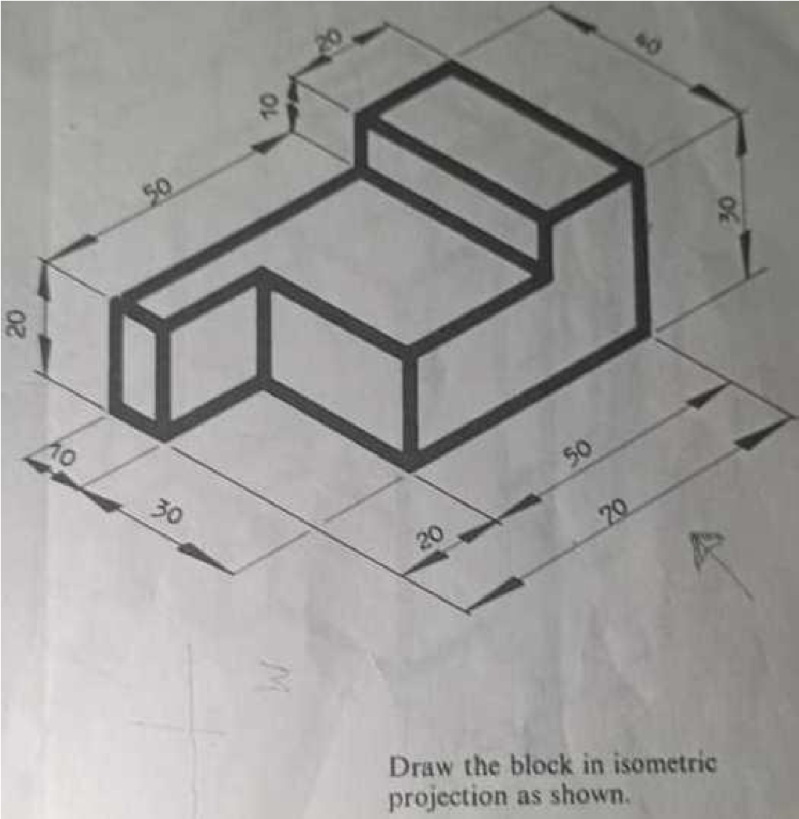

AGRICULTURAL SCIENCE
1a) With the Aid of a labelled diagram, Show Soil profile and its Horizons
1b) Explain the characteristics of each Horizon
2a) Mention and explain two importance of the following to agricultural production Soil air, Soil organisms, Humus content, Soil-water.
3a) Draw and label the following pests of crops, Grasshopper, caterpillar
3b) what are their economic importance
3c) Explain four major factors of agricultural production you know
PHYSICS
- State Hook’s law
- Using the table below, answer the questions that follows
S/N | L(cm) | t₁(s) | t₂(S) | T= $\frac{t1+t2}{2}$(s) | T²(s²)
1 | 10 | 10.5 | 10.0
2 | 20 | 12.2 | 12.5
3 | 30 | 14.3 | 14.0
4 | 40 | 15.9 | 16.0
5 | 50 | 19.0 | 19.1
- Copy and complete the table
- Plot a graph of L(cm) against T²(s²)
- Calculate and define the slope of the graph
- State newton’s law of universal gravitation
CIVIC EDUCATION
- Vividly explain the relationship between NAFDAC and NDLEA as an Agencies that helps in reducing the rate of drug abuse in Nigeria
- Itemize five ways by which citizens exercise their popular participation
- Highlight five importance of popular participation
BIOLOGY
- Define Conservation
- Enumerate five (5) economic importance of tape-worm
- Explain the following
- Pest
- Disease
- In a tabular form state five (5) name of disease, causative agent and symptoms of animals
- Distinguish between sexual reproduction and asexual reproduction
GEOGRAPHY
Draw a map of Nigeria, on the map show
- All 36 states
- River Niger and Benue
- The countries surrounding Nigeria
DATA PROCESSING
- Define Data Modelling
- Explain the different approaches to data modelling
MARKETING
- Define transportation in marketing
- List and explain mode of transportation your know
- List and explain documents used in transport

FURTHER MATHEMATICS
