COMMAND SCIENCE SECONDARY SCHOOL,
LAFIA, NASARAWA STATE
TAKE HOME ASSIGNMENT FOR JSS2.

ENGLISH LANGUAGE
- LETTER WRITING- Your letter should be in between 130-150 words.
Write a letter to your bosom friend in another school, telling him/her about your experiences during your last annual inter-house sports competition.
Construct an envelope, put the letter inside it and address it to your friend.
- Read the book, Thinking Head by Akeem Ajibade comprehensively and summarise it in not more than a page
- Write the passive voice for each of the following active voice below
- The old man killed a snake
- She ate my food
- Esther broke my pencil
- Her mother loves her

CULTURAL AND CREATIVE ART
In your drawing books, draw map of Nigeria and trace locations of Nigerian Traditional Arts.

PHE
- Draw a hockey pitch and identify the following areas
- Side line
- Goal line
- Centre line
- Centre mark
- Mention (5) equipment in the game of hockey
- What is drug abuse
- What is drug misuse
- Briefly explain the game of gymnastics

AGRICULTURAL SCIENCE
- Define forest and explain all the types of forest
- Define farm machinery, state some farm machineries and their uses
- Draw and label atleast two(2) farm machineries you know
- A. Define farm storage
- What are the factors affecting farm storage
- Draw any storage structure you know

HISTORY
- Discuss the early origin and history of Songhai Empire
- Locate the Map Songhai Empire on the Map of Africa
- Discuss the factors that led to the rise and fall of Songhai

CIVIC EDUCATION
Explain features of two Colonial Constitutions.
List three features of Independence Constitutions.

IRS
- Give brief biography of the following scholars
- Sheikh El-kanemin (Muhammad) Al-Amin Ibn Muhammad of Borno
- Sheikh Shilta Bay and His contribution to Islam
- Explain the word Fasting and its types

CRS
- Discuss the convention of Paul
- Narrate Paul’s first and second missionary journey
3a. Define Conflict
b. Explain wrong ways and right ways of resolving conflict

HAUSA LANGUAGE
- Kawo sunayen abincin gargajiyar ku, guda goma (10) ka/ki bayyana yadda ake yin biyu daga ciki
- Bayyana tsarin sarautar gargajiya na garinku
- Zayyana bukukuwan al’adarku tare da yin bayani

FRENCH LANGUAGE
Tell the following [time] in French
- It is 3;45 am
- It is 5;55 am
- It is 9;15 am
- It is 6;30 am
- It is 2;00 am

BUSINESS STUDIES
1a. What are re-ocuring expenses?
b What type of bank account facilitate monthly deductions on re-occuring expenses
2 Explain the following terms
- Indemnity
- Premium
- Asurred
- Utmost good faith
3 List 5 benefits of insurance
4a What are bank account?
b Explain the following types of account
- Fixed Account
- Current Account
- Savings Account
5 Explain the following
- Quotation
- Reciept
- Invoice

HOME-ECONOMICS
1a. List the 6 food nutrients
b Write 4 sources of each food nutrient
c Write 2 functions of each food nutrient
2a Write some common deficiencies associated with each of the food nutrients and their remedies

BASIC SCIENCE
- Define Flooding and states 4 causes of flooding
- List 5 effect and 5 prevention of flooding
- Define Drainage Pattern and list and explain 3 main types of drainage pattern

SOCIAL STUDIES
BROWN- With the aid of a well-drawn diagram, show a group of people living in peace and harmony. [Use a cardboard paper].
YELLOW-With the aid of a well-drawn diagram, show a group of people having conflict. [Use a cardboard paper].

MATHEMATICS
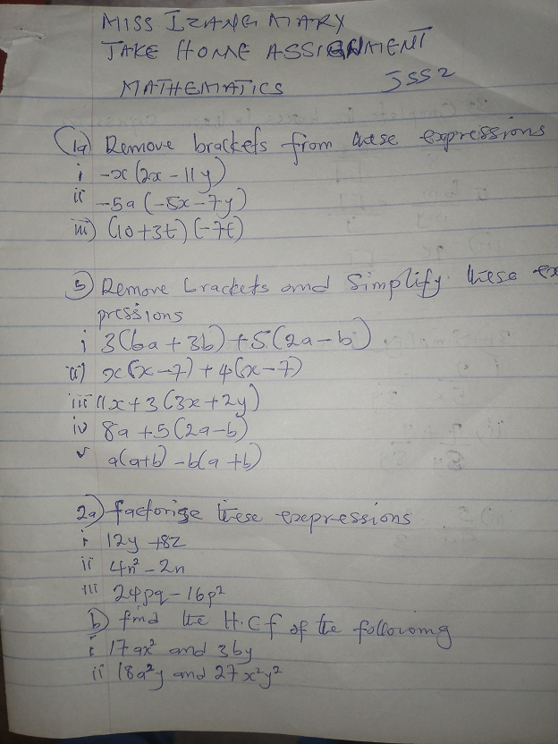

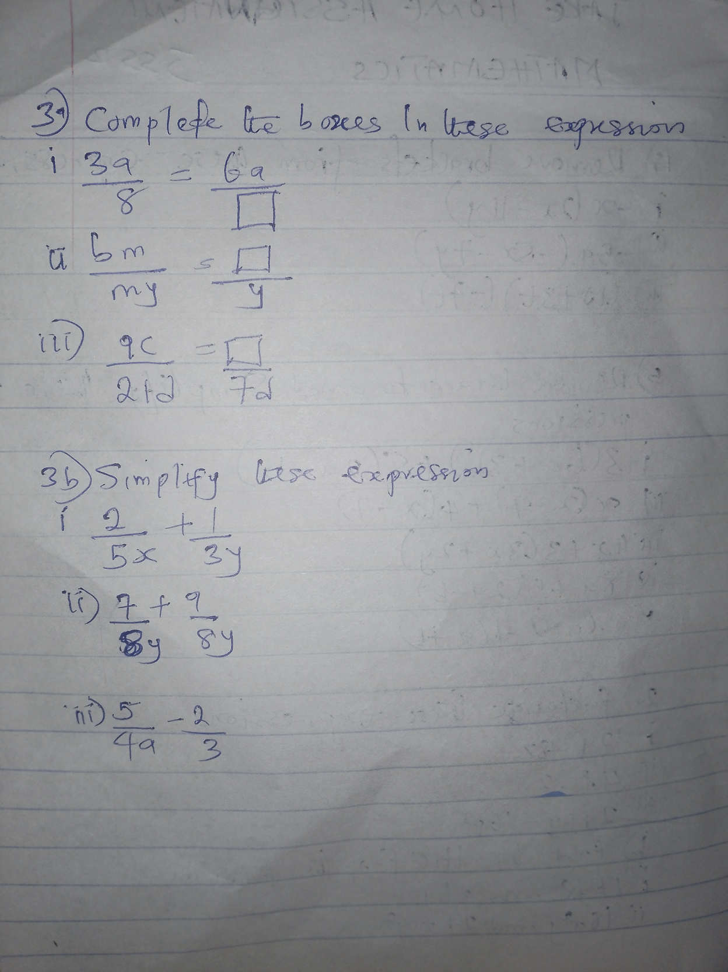

COMPUTER STUDIES
- Define Internet
- List 5 uses of the internet
- What is a search engine
- Define file sharing
- List 2 types of file sharing
- What is a network
- List 4 types of networks and explain them

BASIC TECHNOLOGY
1A. Belt Drives = Advantages and Disadvanges
B Chain Drives = Advantages and Disadvanges
C Application of Belt and Chain Drives
What is Geometric Construction
- Tangent
- Radius
- Diameter
- Chord
- Segment

