- What is the place value of 7 in the number 526. 974?
- A cuboid has _____ vertices
- Find the positive difference between -8 and -14
4. The diagram below is a----
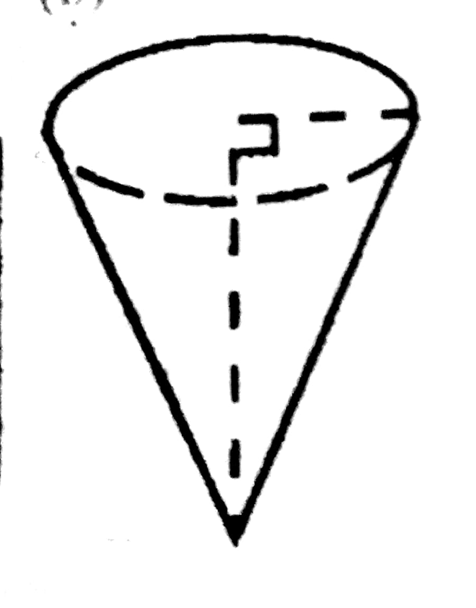
5. Approximate 0.007849 to 3 significant figures
6. Find the value of 16 x 2 - 3 + 14 ÷ 7
7. What is the coefficient of y in $\frac{2y}{3}$
9. Find the value of m - 12 + m x 2 when m = 15
10. Simplify -3 -(-21) - 18
11. Find the value of g if 3g +g = 6g + 8g -9g + 30
12. Simplify 6x - 5x + x - 2x
13. Simplify ⅖ of 20ab
14. If 8 is added to a number, the result is 18, find the number
15. Solve x - 10 = 26
16. Give 3.9997 correct to 3 d.p
17. What is the coefficient of y in 3x - y
18. Solve 7d - 5 = 30
19 Remove bracket from 12(m - 2n)
20. Simplify 3p x 5q x 4r
21. Round up 799472 to the nearest thousand
22. Simplify 14v - 6v + 6v - 8v + 7v - 4v
23. Copy and complete the table below
S/N | No. of vertices | No. of faces | No. of edges
1. | cube
2. | cuboid
3. | cone
4. | Triangular prism

