22ND January, 2021
PRESCHOOL ASSIGNMENT
Name: _____________________________

INSTRUCTION: IDENTIFY THE SHAPE AND COLOUR IT BLUE.
HOW MANY SIDES DOES THE SQUARE HAVE? _____________________
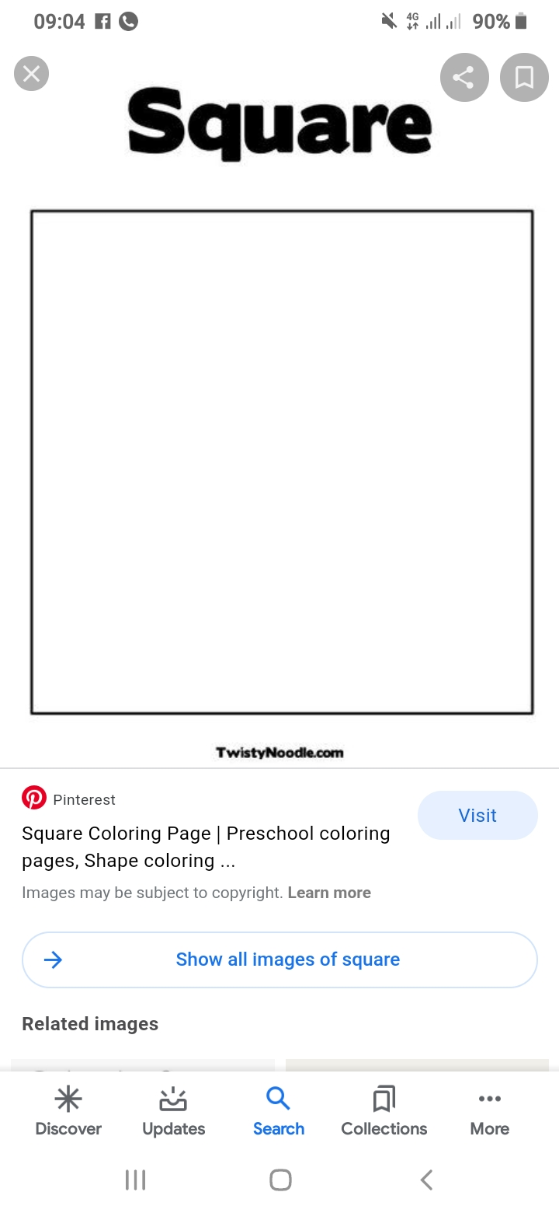
How many sense organs do we have? _____________________________________
Mention them ____________________________________________________________

